WEEK 1 – POWER BI REPORT (E25DA048)
- Power BI Desktop was launched to initiate the process of importing, cleaning, transforming, and preparing the Superstore Sales dataset for analysis.
Power BI Desktop home screen, marking the start of the data import and preparation workflow
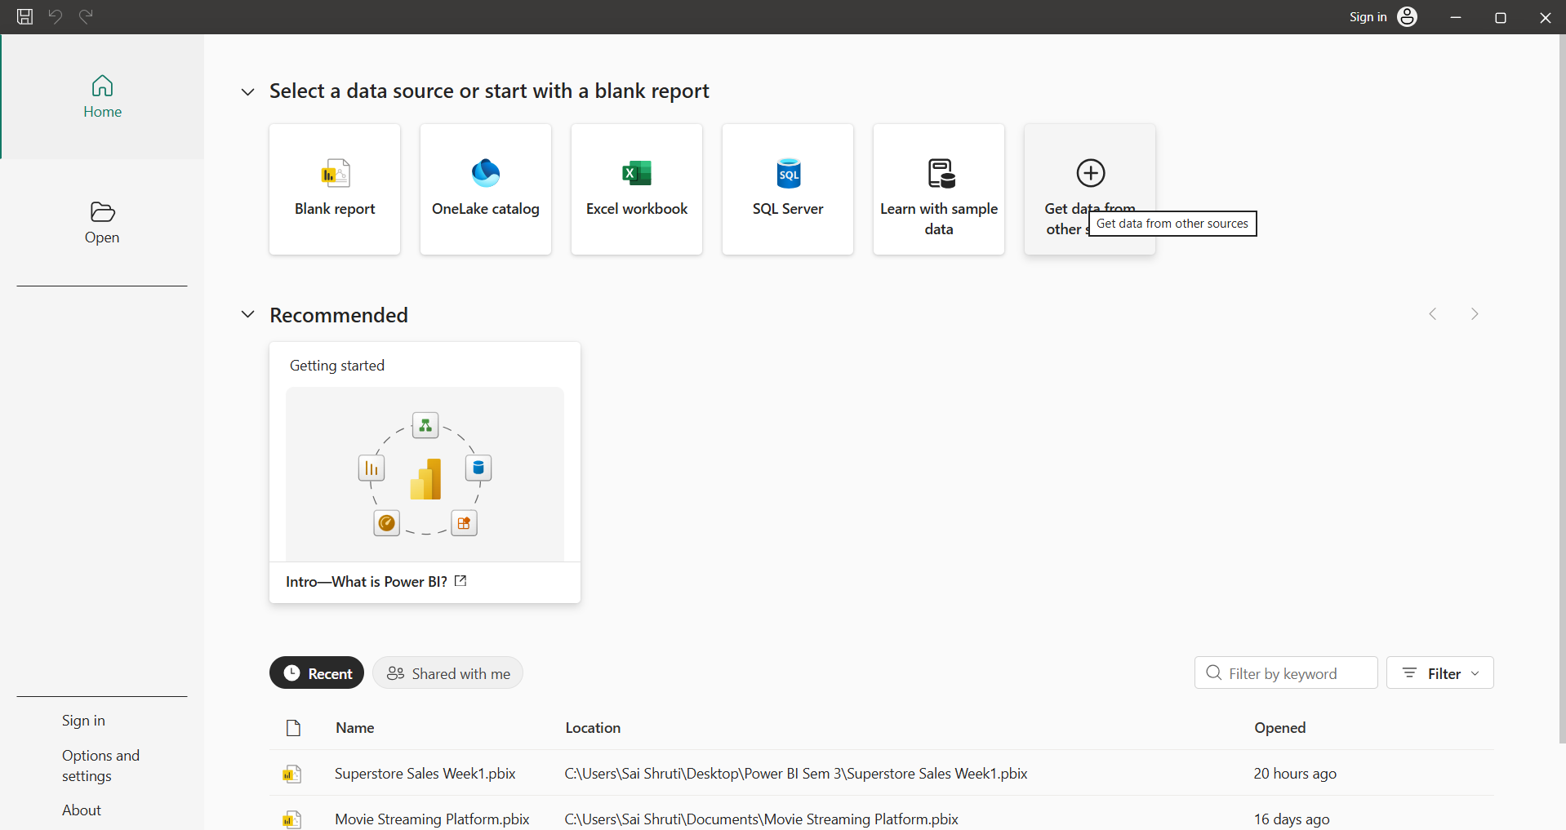
- The Superstore Sales dataset was imported into Power BI using the Text/CSV data source option, with the relevant CSV file selected from the local system.
Selection of the Superstore Sales CSV file for import into Power BI
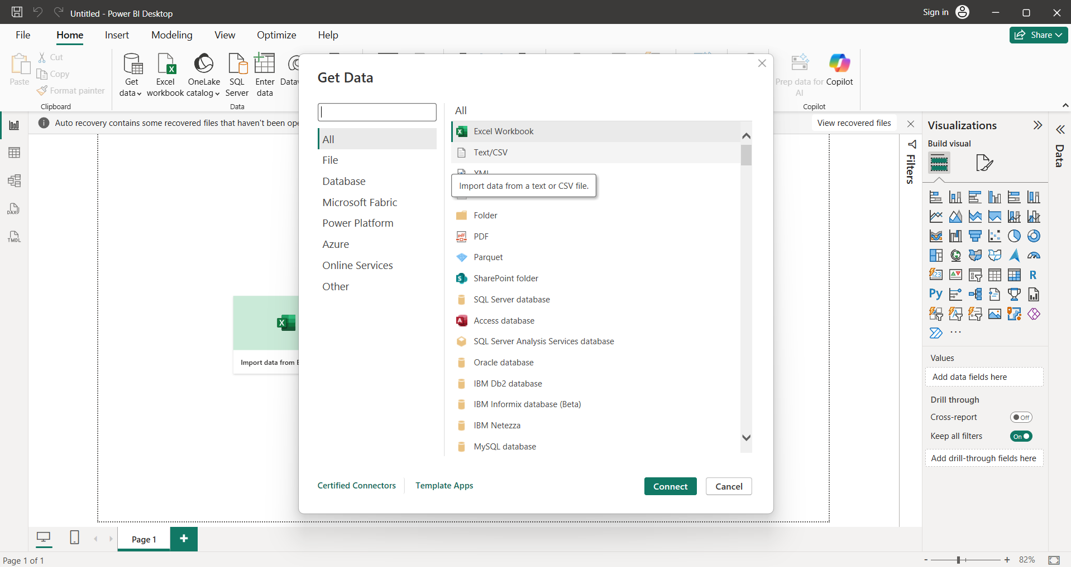
- 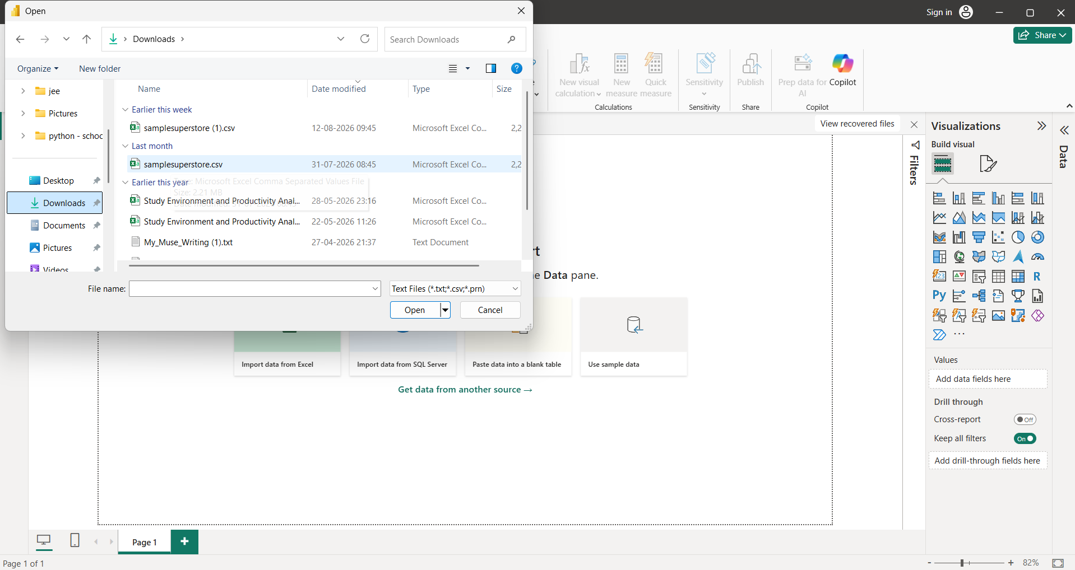
- Prior to loading, the contents of the CSV file were previewed to verify the available columns and records. The dataset was confirmed to encompass sales, customer, product, geographic, and profitability information.
Preview of the Superstore Sales dataset prior to transformation
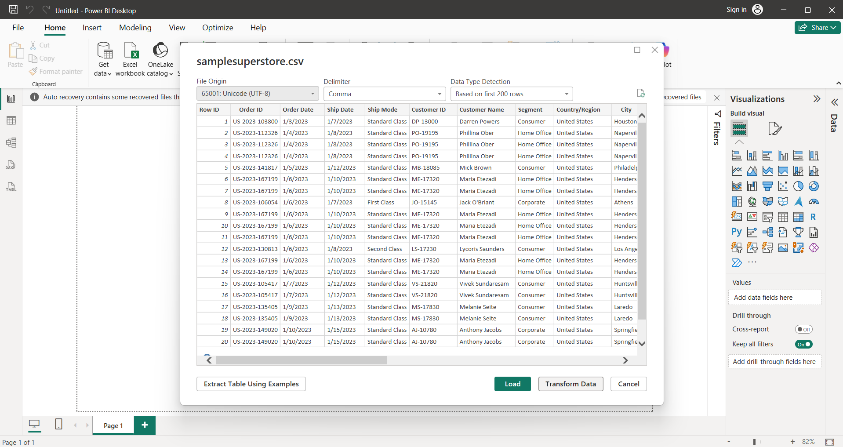
- The Transform Data option was selected to open Power Query Editor, which was subsequently used to inspect the dataset and carry out the required data-cleaning and transformation procedures.
The dataset was examined within Power Query Editor to assess its structure, column composition, data types, and overall data quality. The dataset comprises 10,194 records across 21 columns.
Column quality indicators within Power Query were used to evaluate the proportion of valid values, errors, and empty values, ensuring that missing values and data inconsistencies were identified prior to performing further transformations.
Superstore Sales dataset opened in Power Query Editor
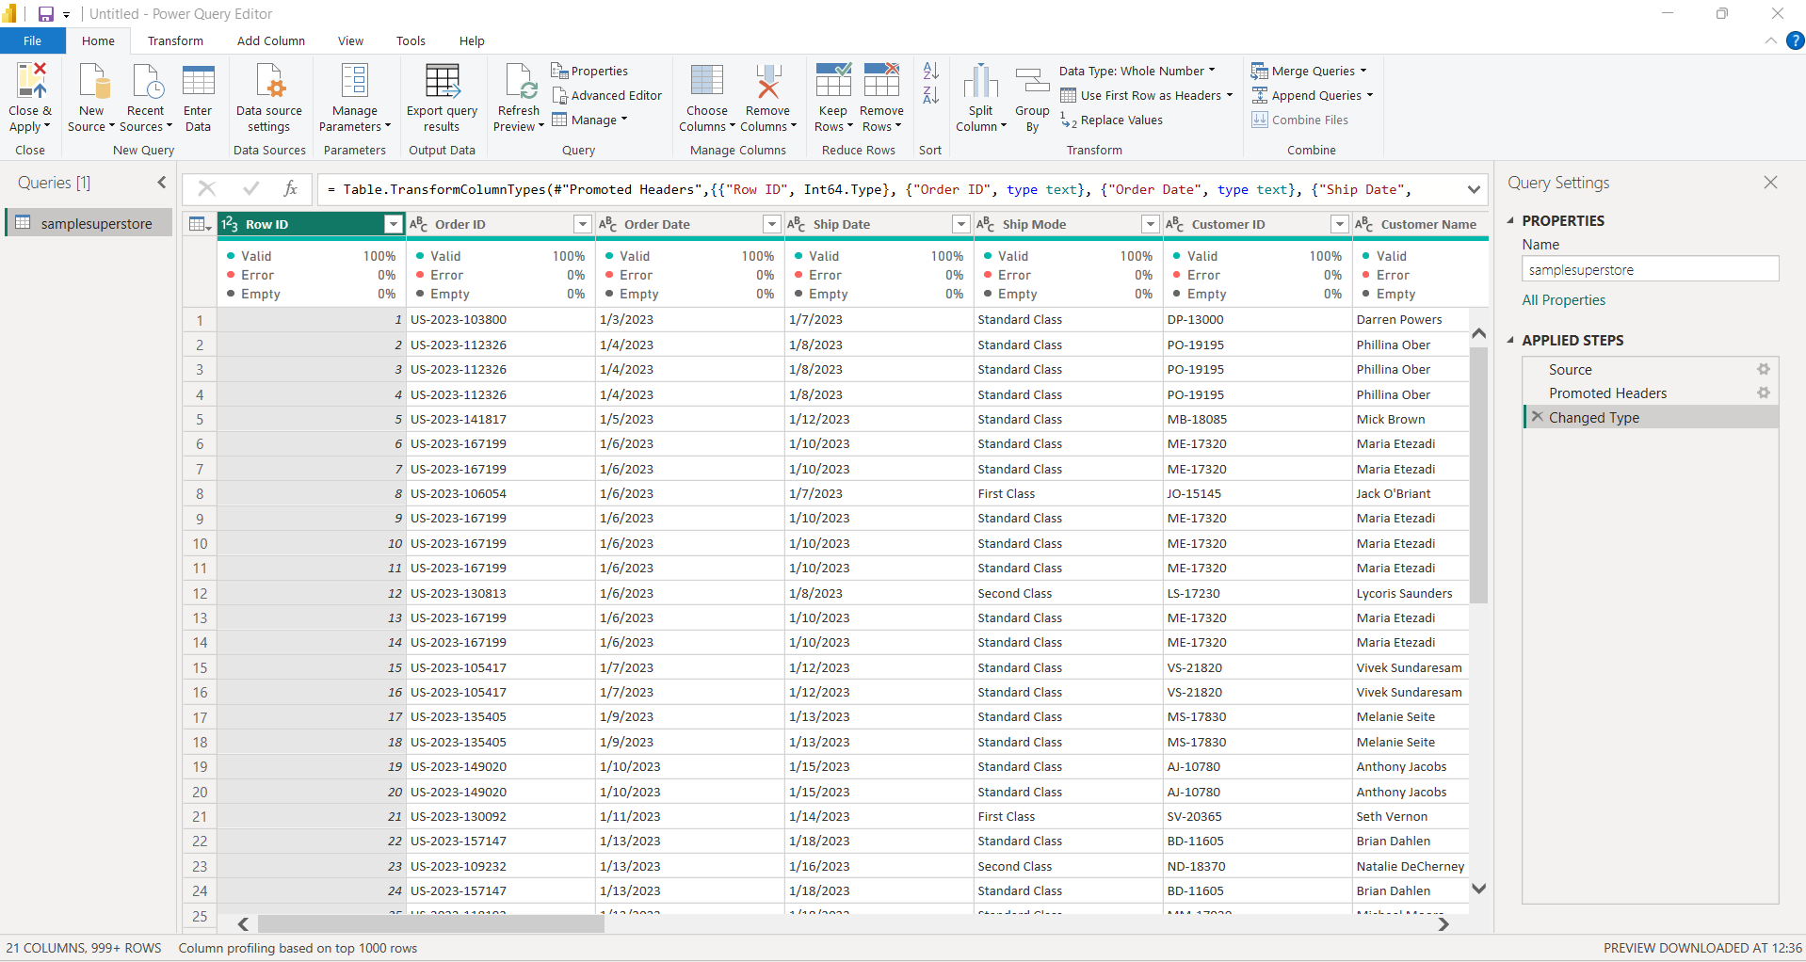
- The Order Date and Ship Date columns were converted to the Date data type using the English (United States) locale, ensuring accurate interpretation of the date values contained within the CSV file.
Order Date and Ship Date converted to Date format using the appropriate locale
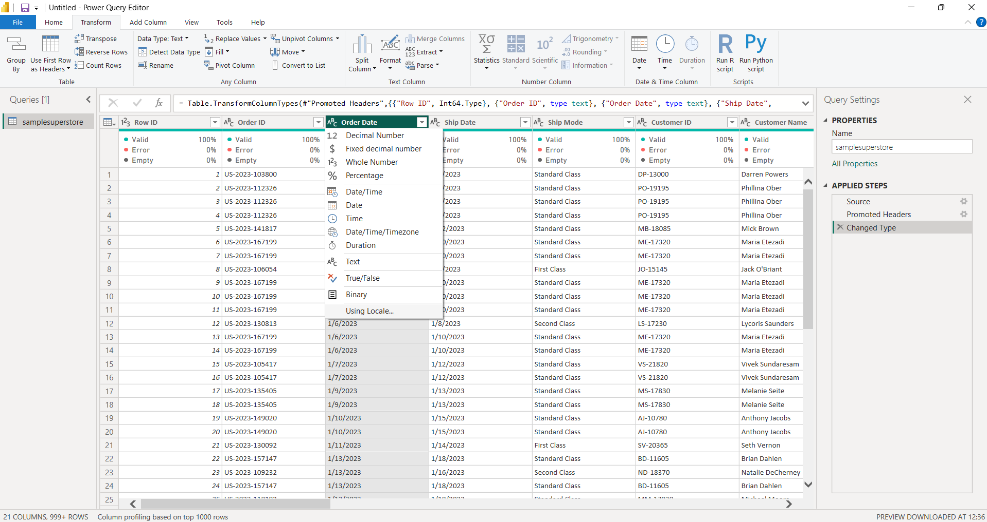
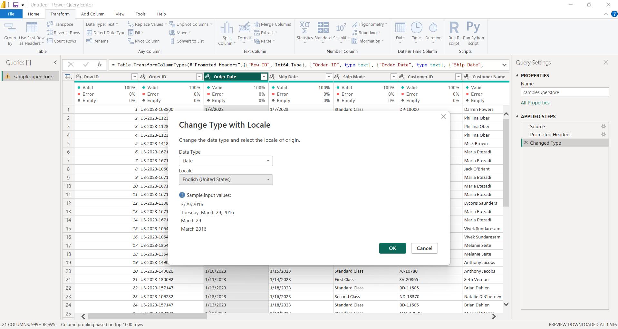
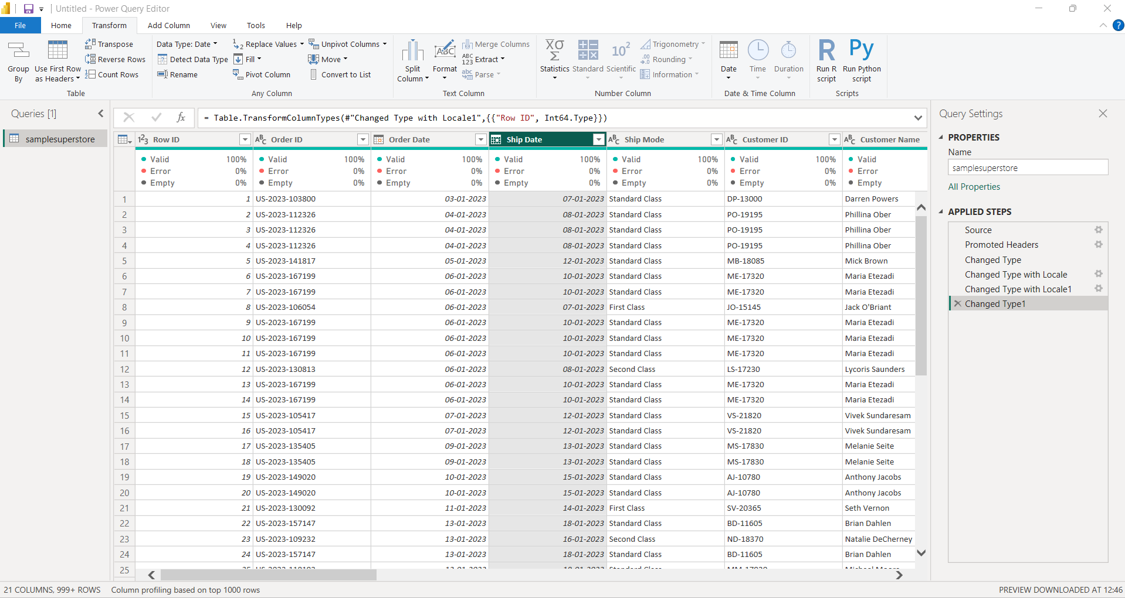
- Appropriate data types were assigned across all dataset columns: date fields were set to Date, numerical fields such as Sales and Profit were converted to Decimal Number, Quantity was converted to Whole Number, and identifier fields such as Customer ID and Product ID were retained as Text.
Appropriate data types assigned to the Superstore dataset columns
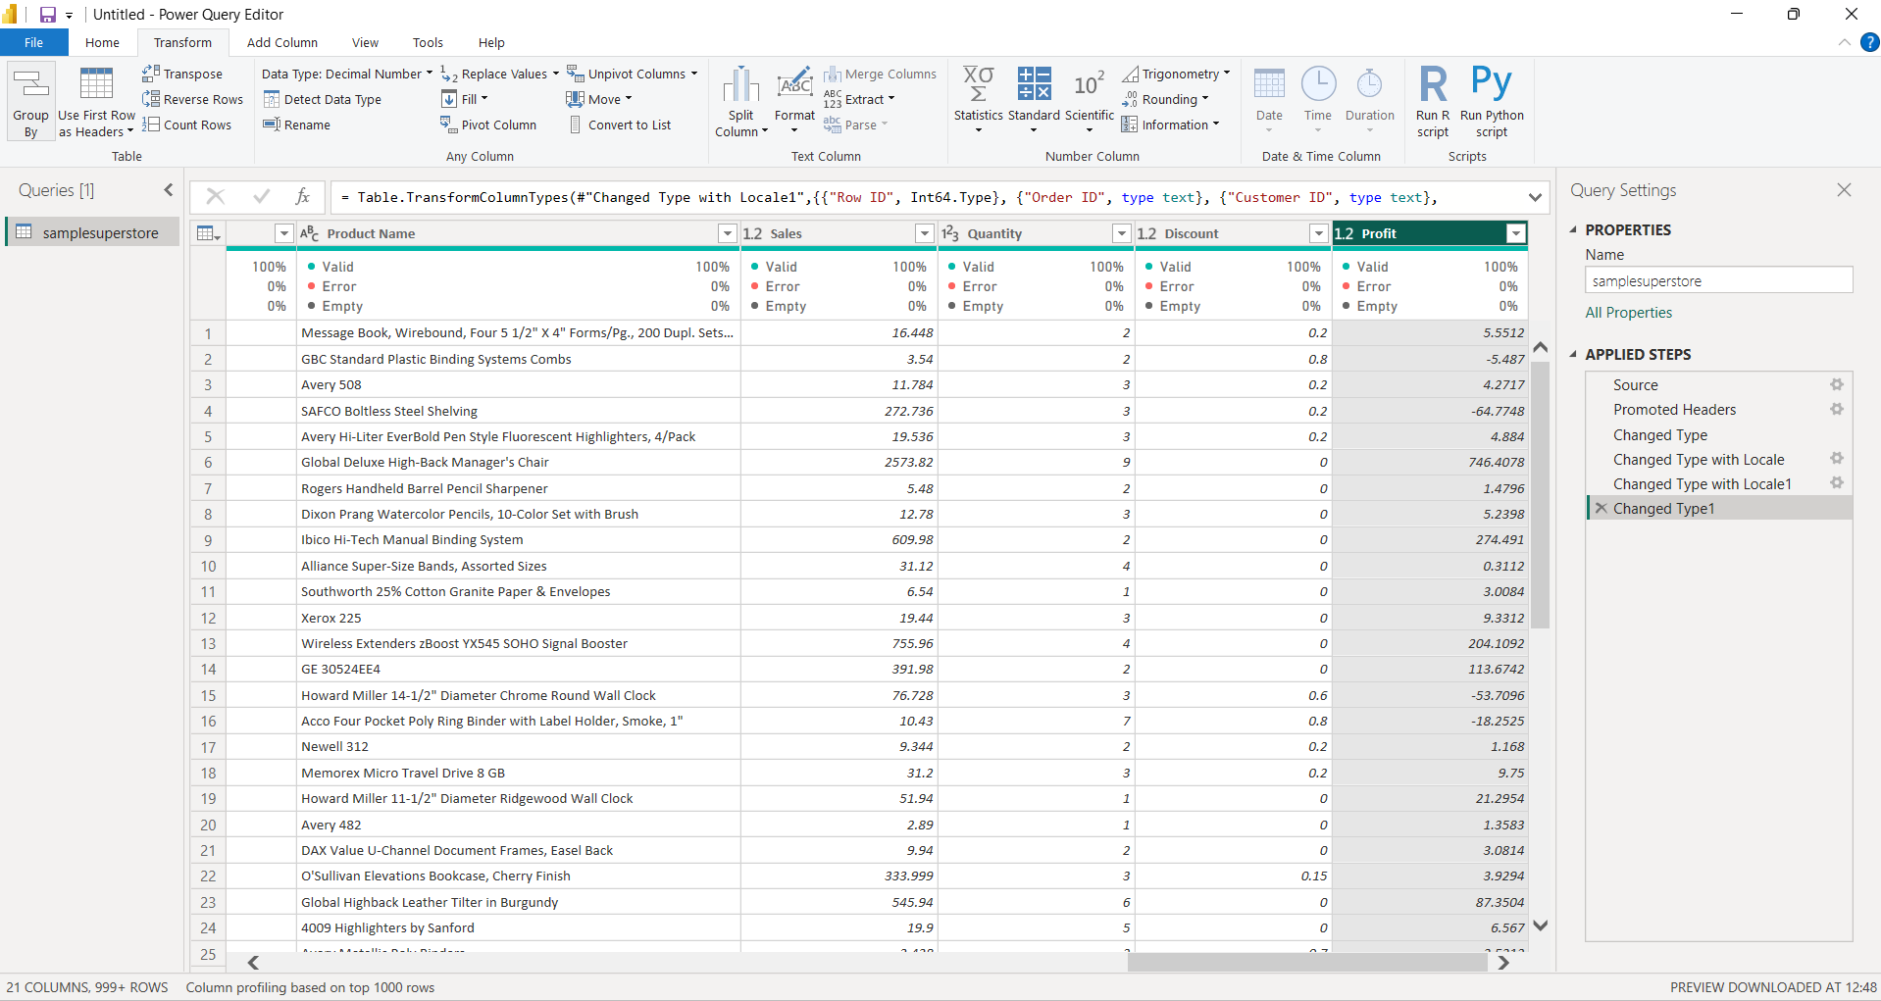
- Text-based categorical fields were standardized using the Trim and Clean transformations available in Power Query. Columns including Category, Sub-Category, Segment, and Region, among other relevant text fields, were cleaned to eliminate extraneous spaces and non-printing characters.
Text fields standardized using Trim and Clean transformations
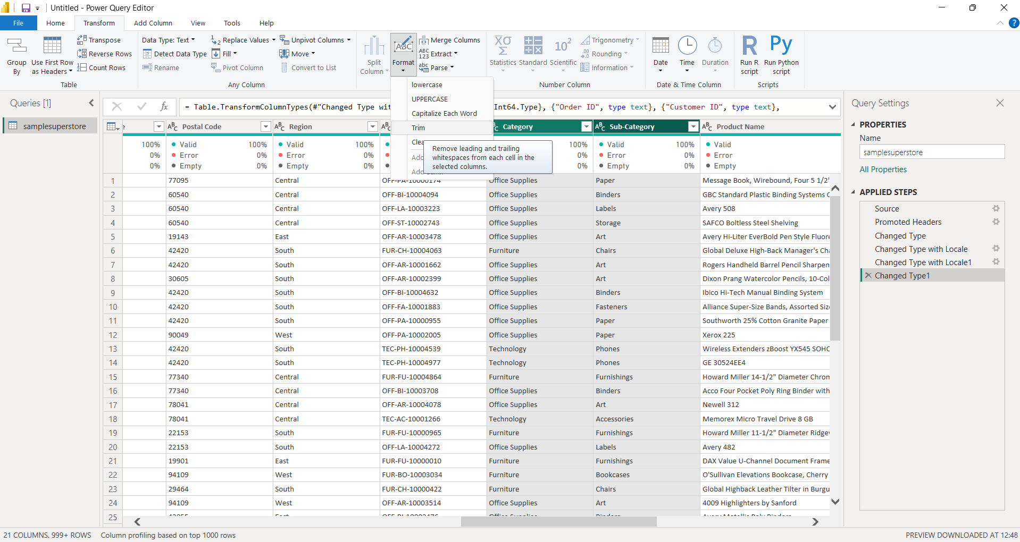
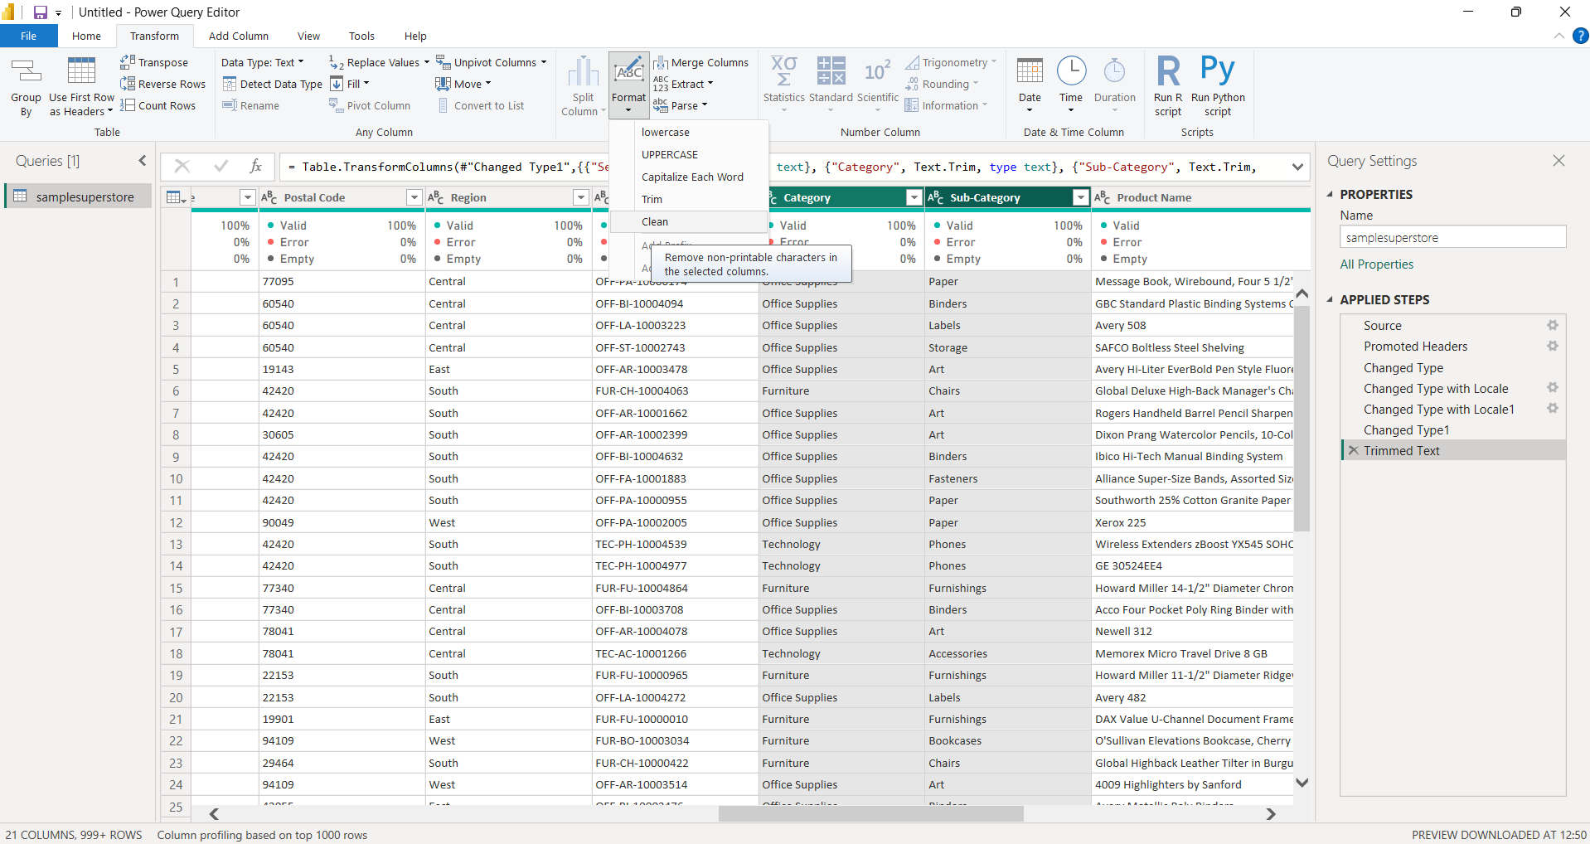
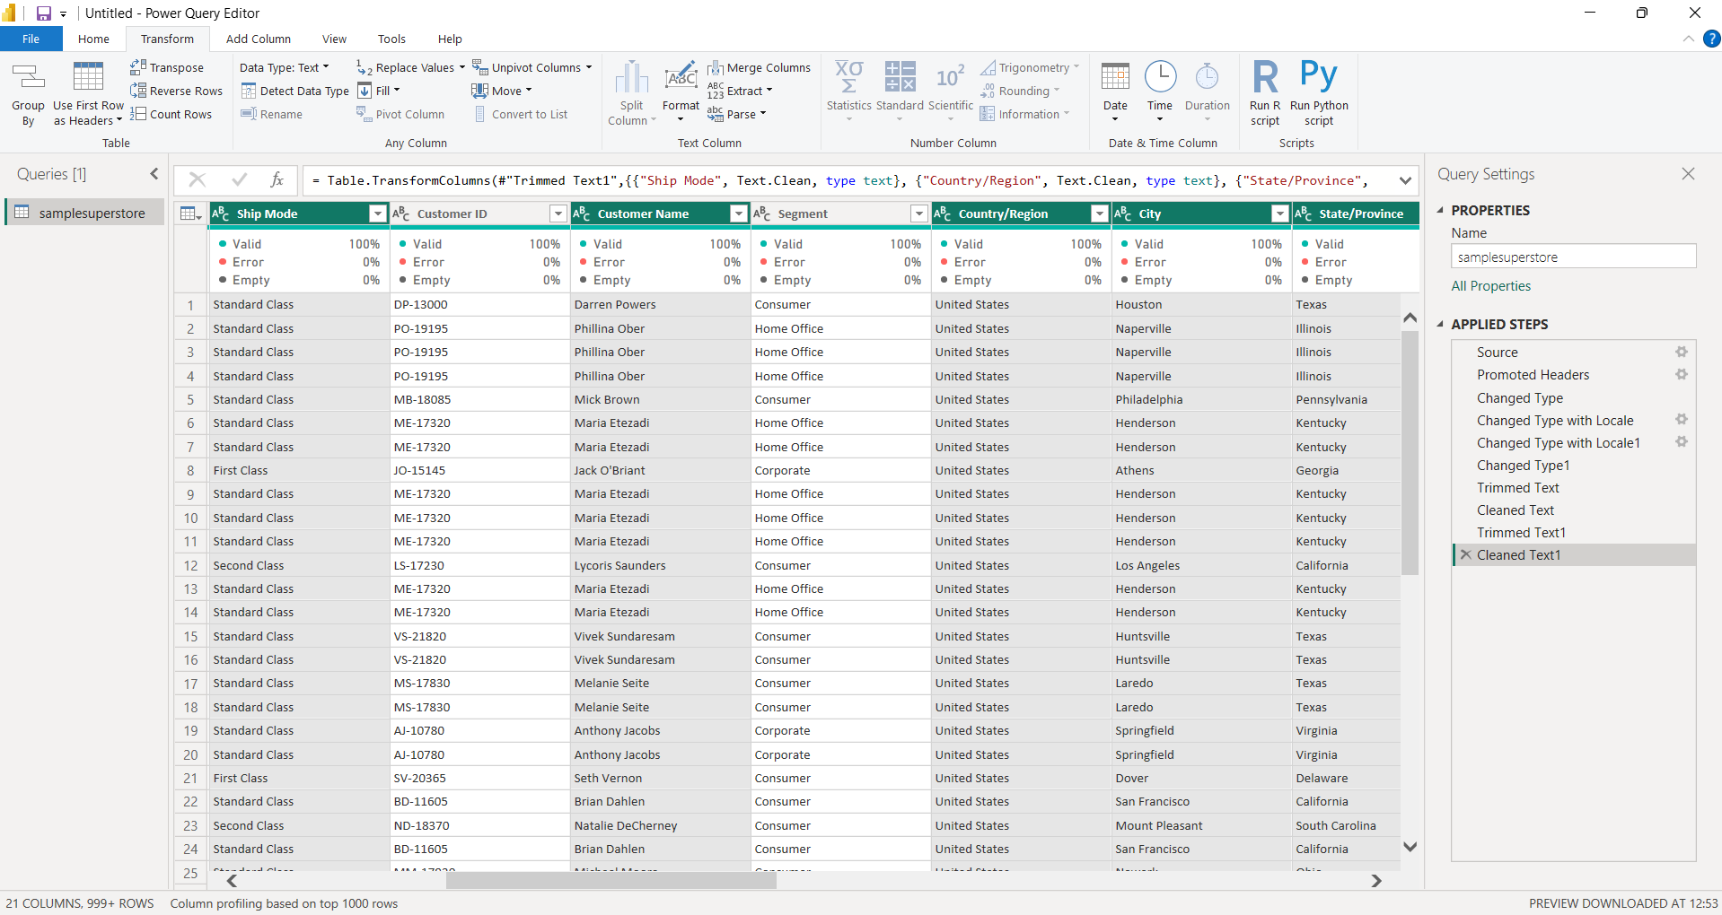
- A new Order Year column was derived from the Order Date column using the Date transformation options available in Power Query.
Order Year extracted from the Order Date column
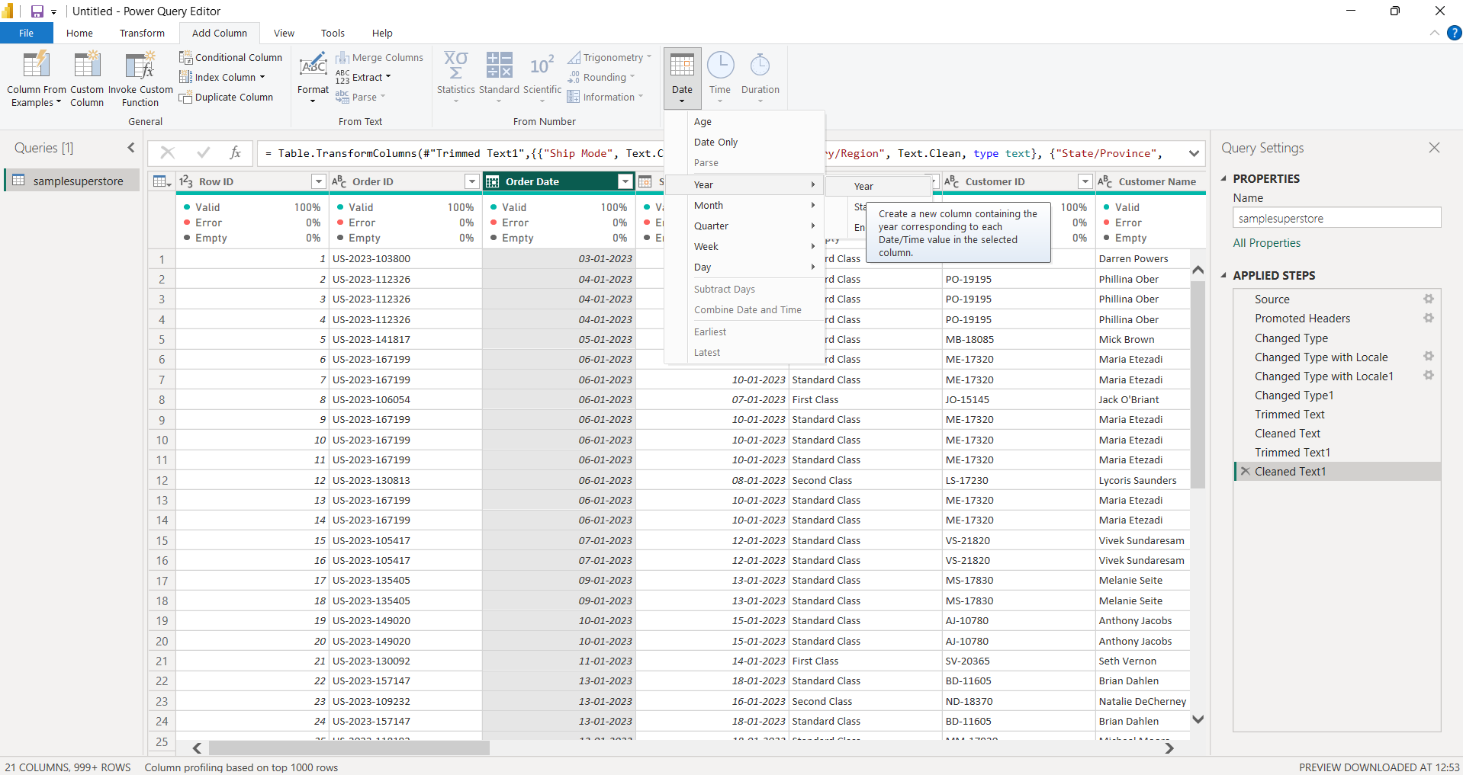
- The column was subsequently renamed to Order Year.
- Quarter-level information was extracted from the Order Date column, generating both a numerical quarter value and a formatted representation (Q1, Q2, Q3, Q4) for subsequent analysis. These columns were renamed to Order Quarter Number and Order Quarter, respectively.
Quarter attributes created from Order Date
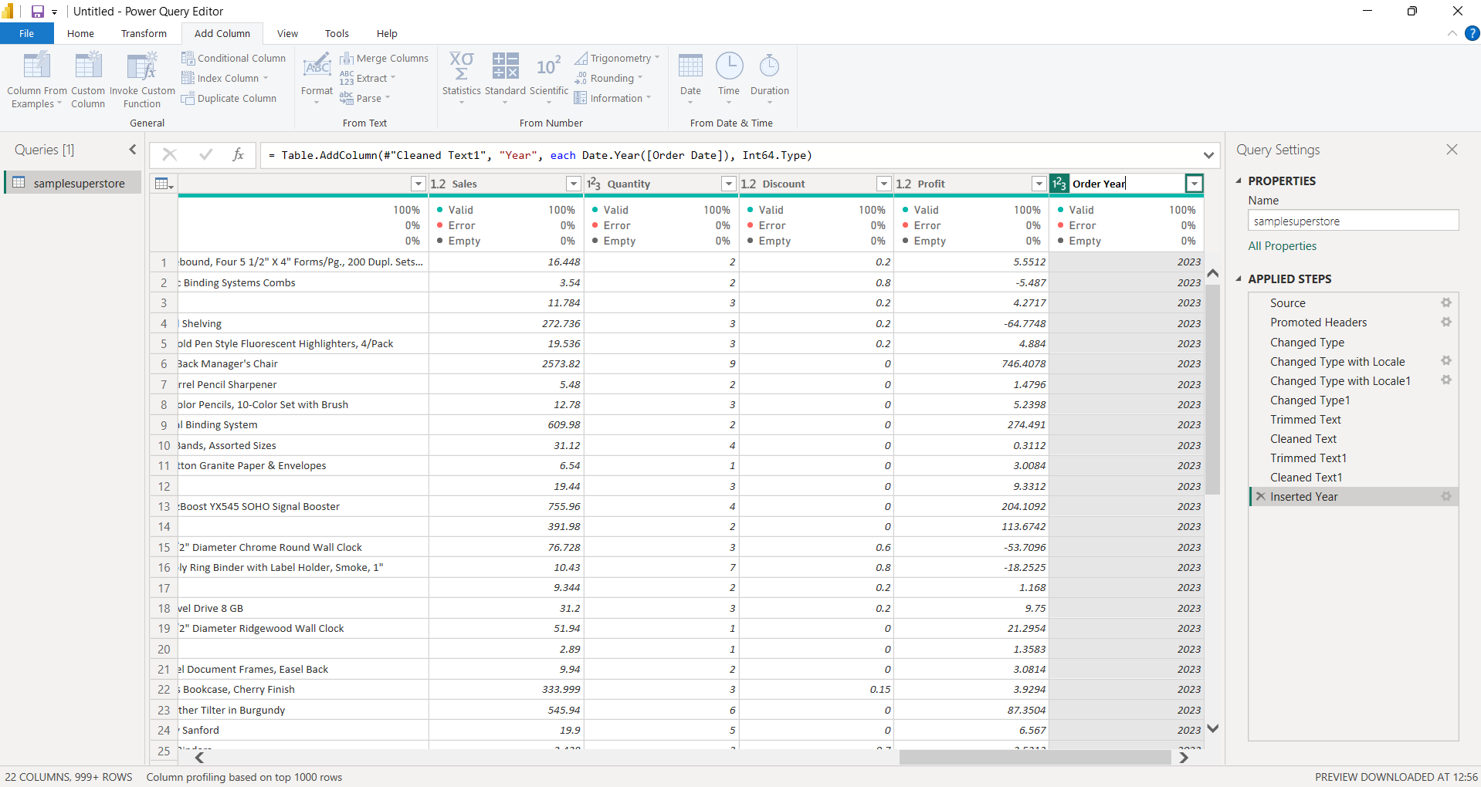
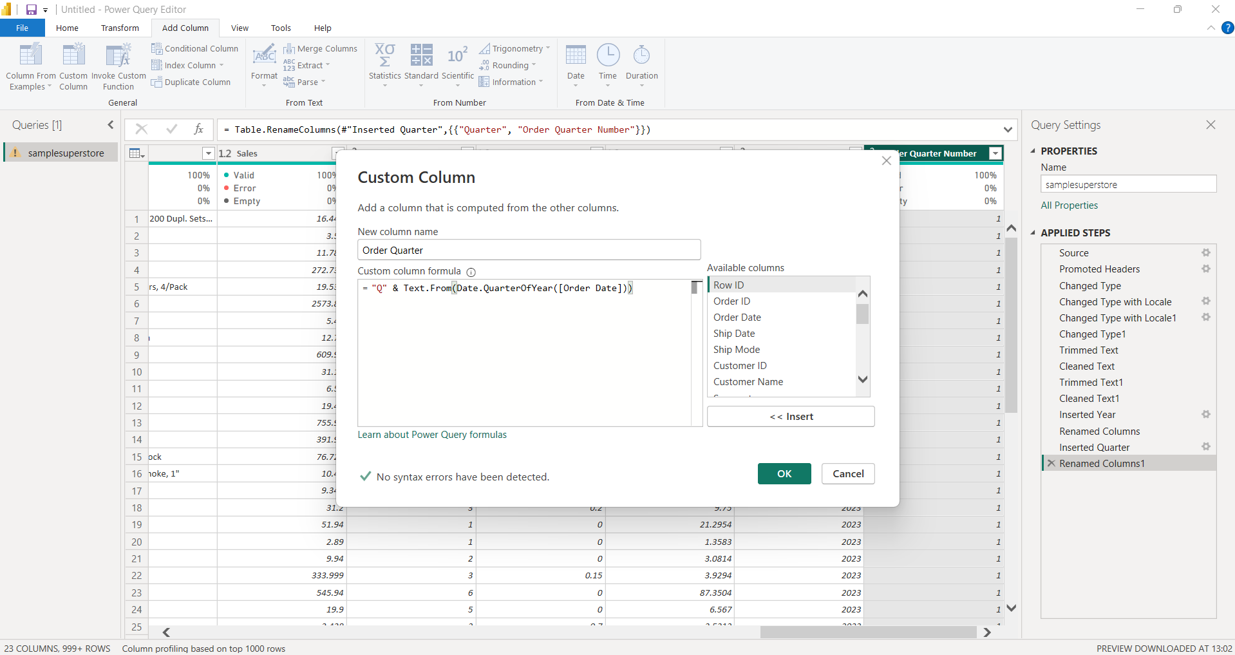
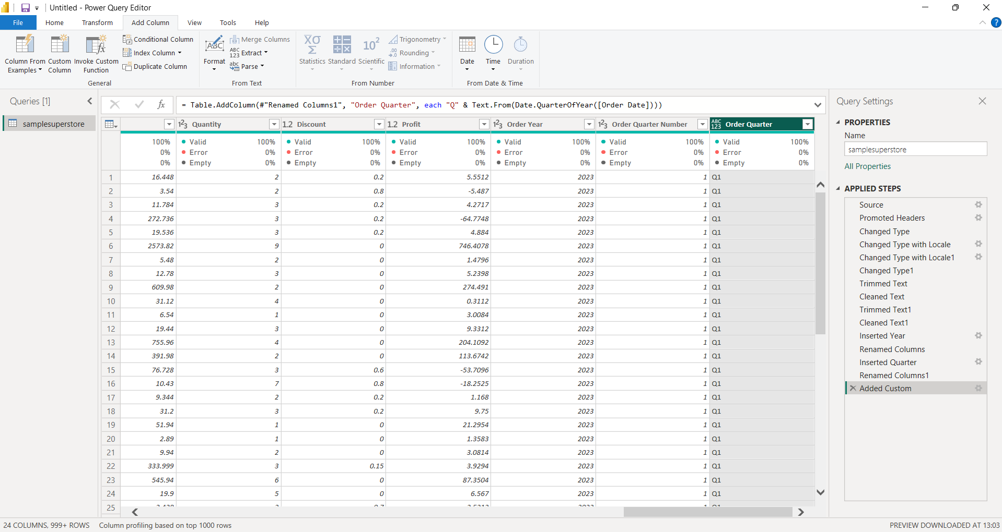
- Month-level attributes were extracted from the Order Date column, with Month Number and Month Name columns created to facilitate chronological analysis and visualization.
- Day-level attributes were similarly extracted from the Order Date column, with Day and Day of Week columns created to enable analysis at the individual day and weekday level.
- The resulting transformed dataset contains all required temporal attributes, namely Order Year, Order Quarter, Order Month Number, Order Month, Order Day, and Order Day of Week.
Final temporal attributes extracted from the Order Date field
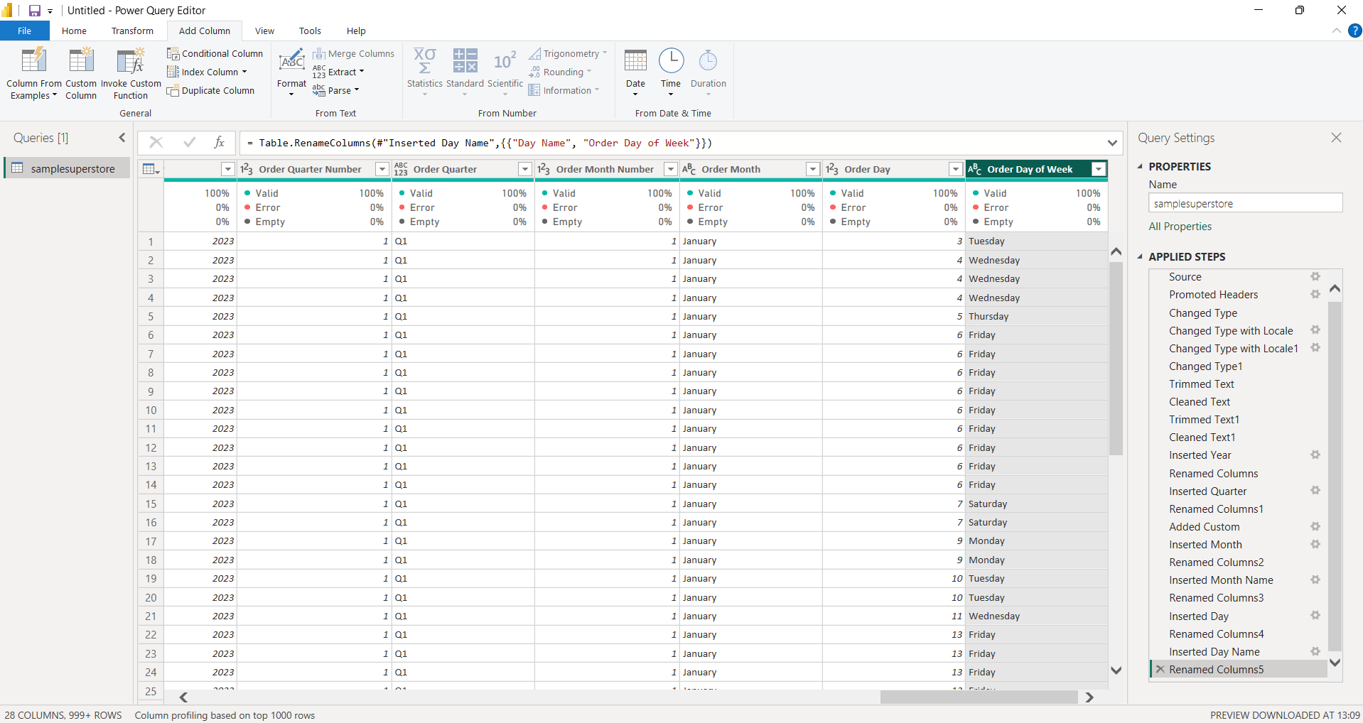
- The Applied Steps panel was reviewed to confirm the sequence of transformations applied to the dataset, documenting the data type changes, text cleaning, renaming, and date attribute creation carried out throughout the data preparation process.
- 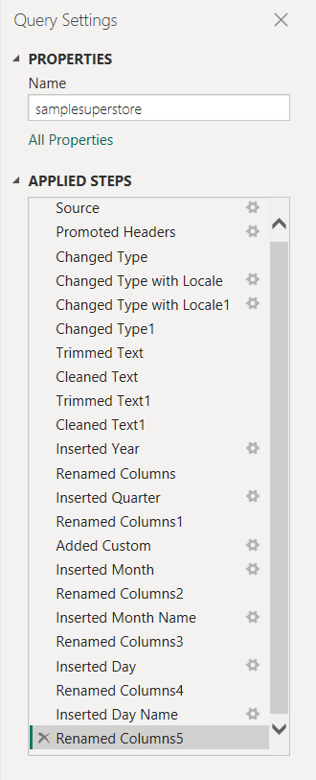
Applied Steps showing the sequence of data transformations performed in Power Query
- Upon completion of the transformations, the final dataset was reviewed to confirm that all required columns were present and that the transformed values were displayed accurately.
- 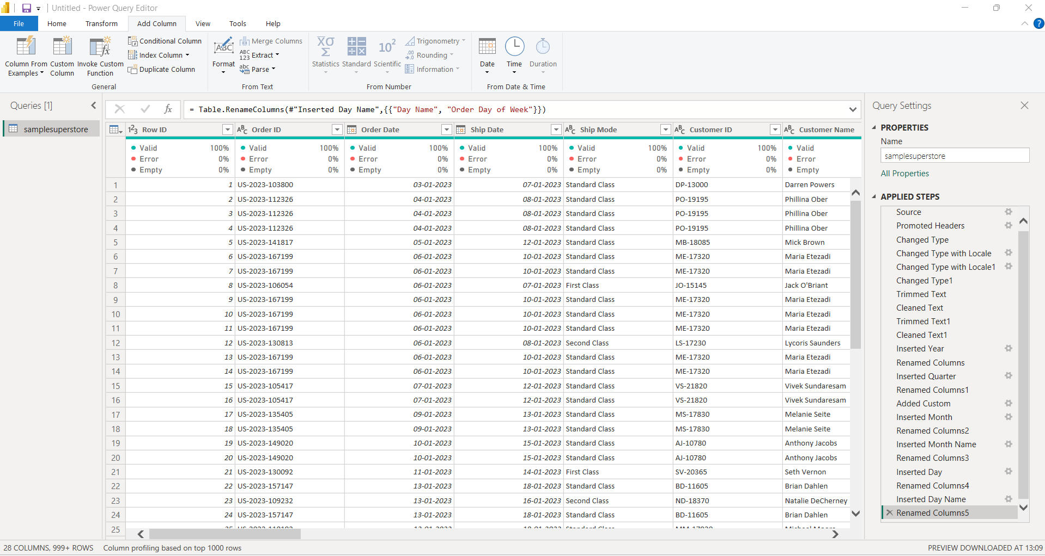
Final cleaned and transformed Superstore dataset in Power Query
- Following completion of the required transformations, the Close & Apply function was used to load the cleaned dataset into the Power BI data model.
- 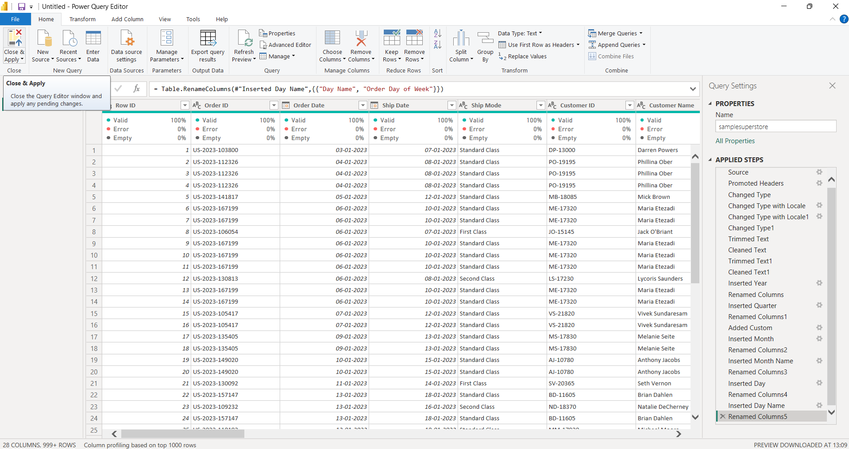
Closing Power Query and applying the transformations to the Power BI data model
- The Report View was subsequently opened, providing the environment used to create visualizations and build the business intelligence dashboard.
Power BI Report View after loading the transformed dataset
- 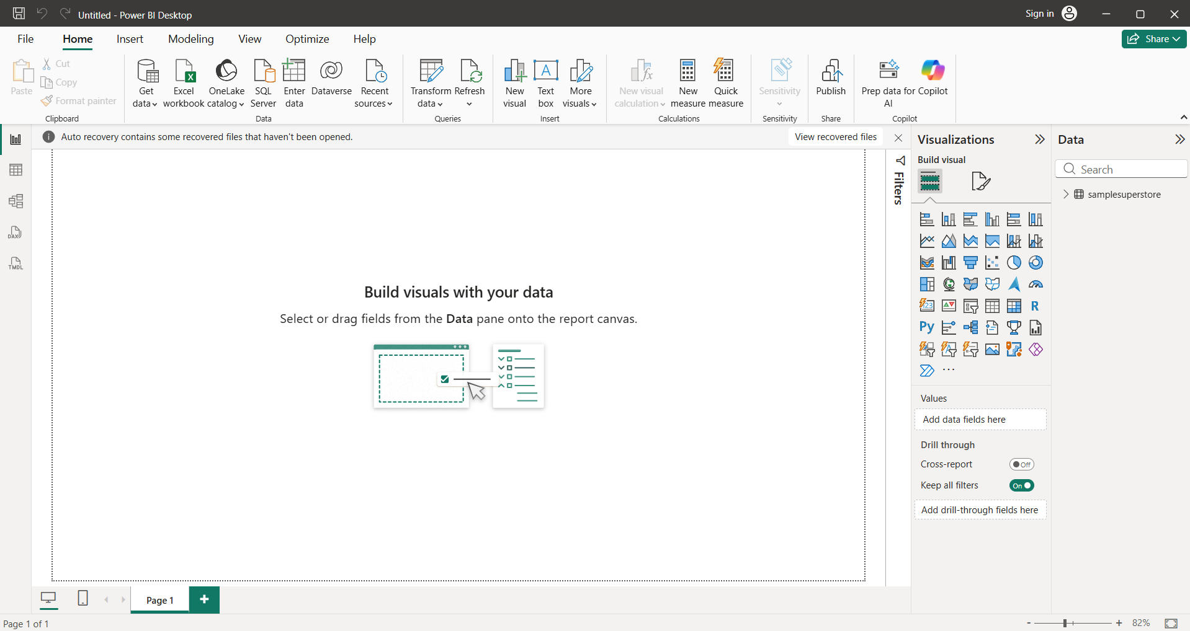The Data View was used to confirm that the cleaned and transformed dataset had been successfully loaded into Power BI.
Data View displaying the loaded Superstore dataset
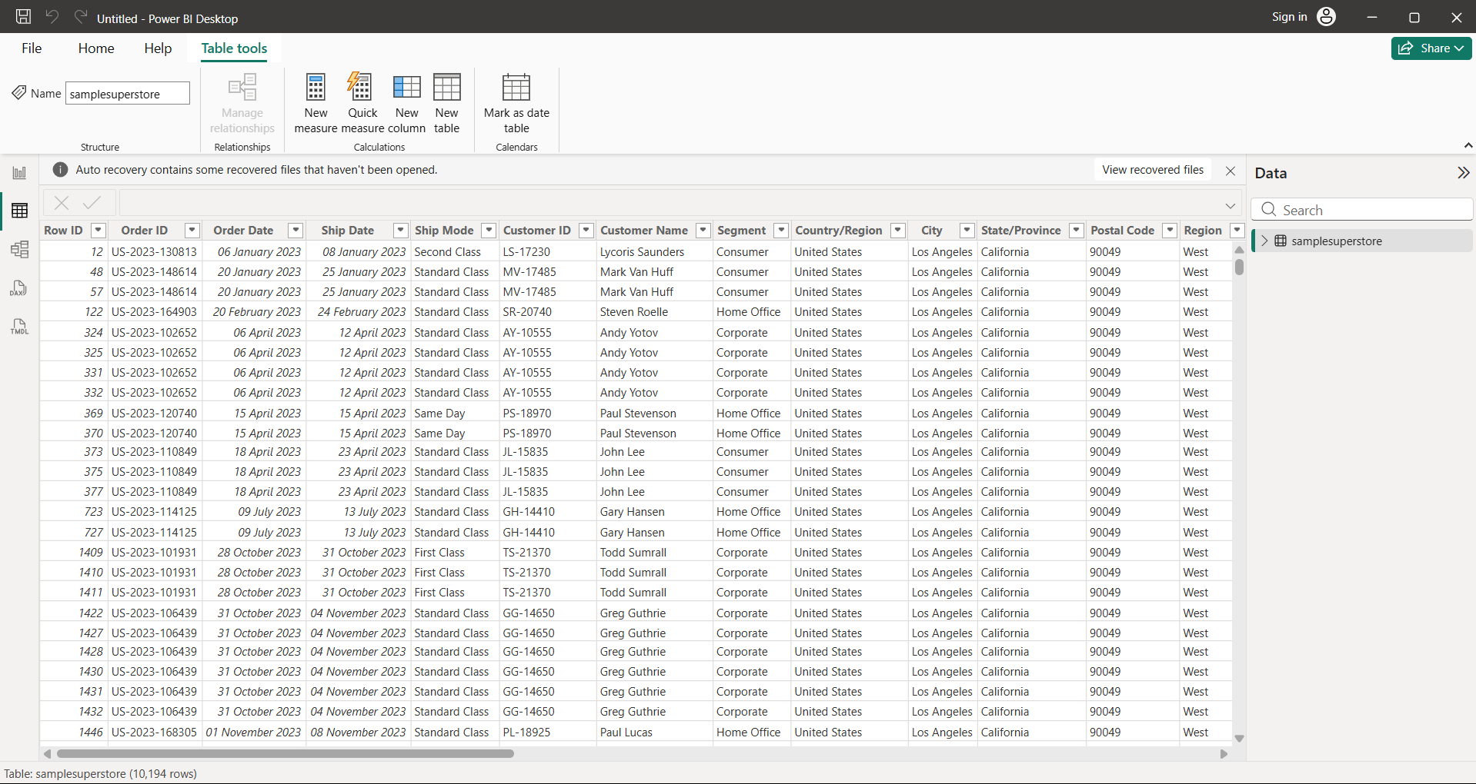
- The Model View was examined to verify the structure and integrity of the resulting data model.
Model View showing the Superstore dataset in the Power BI data model
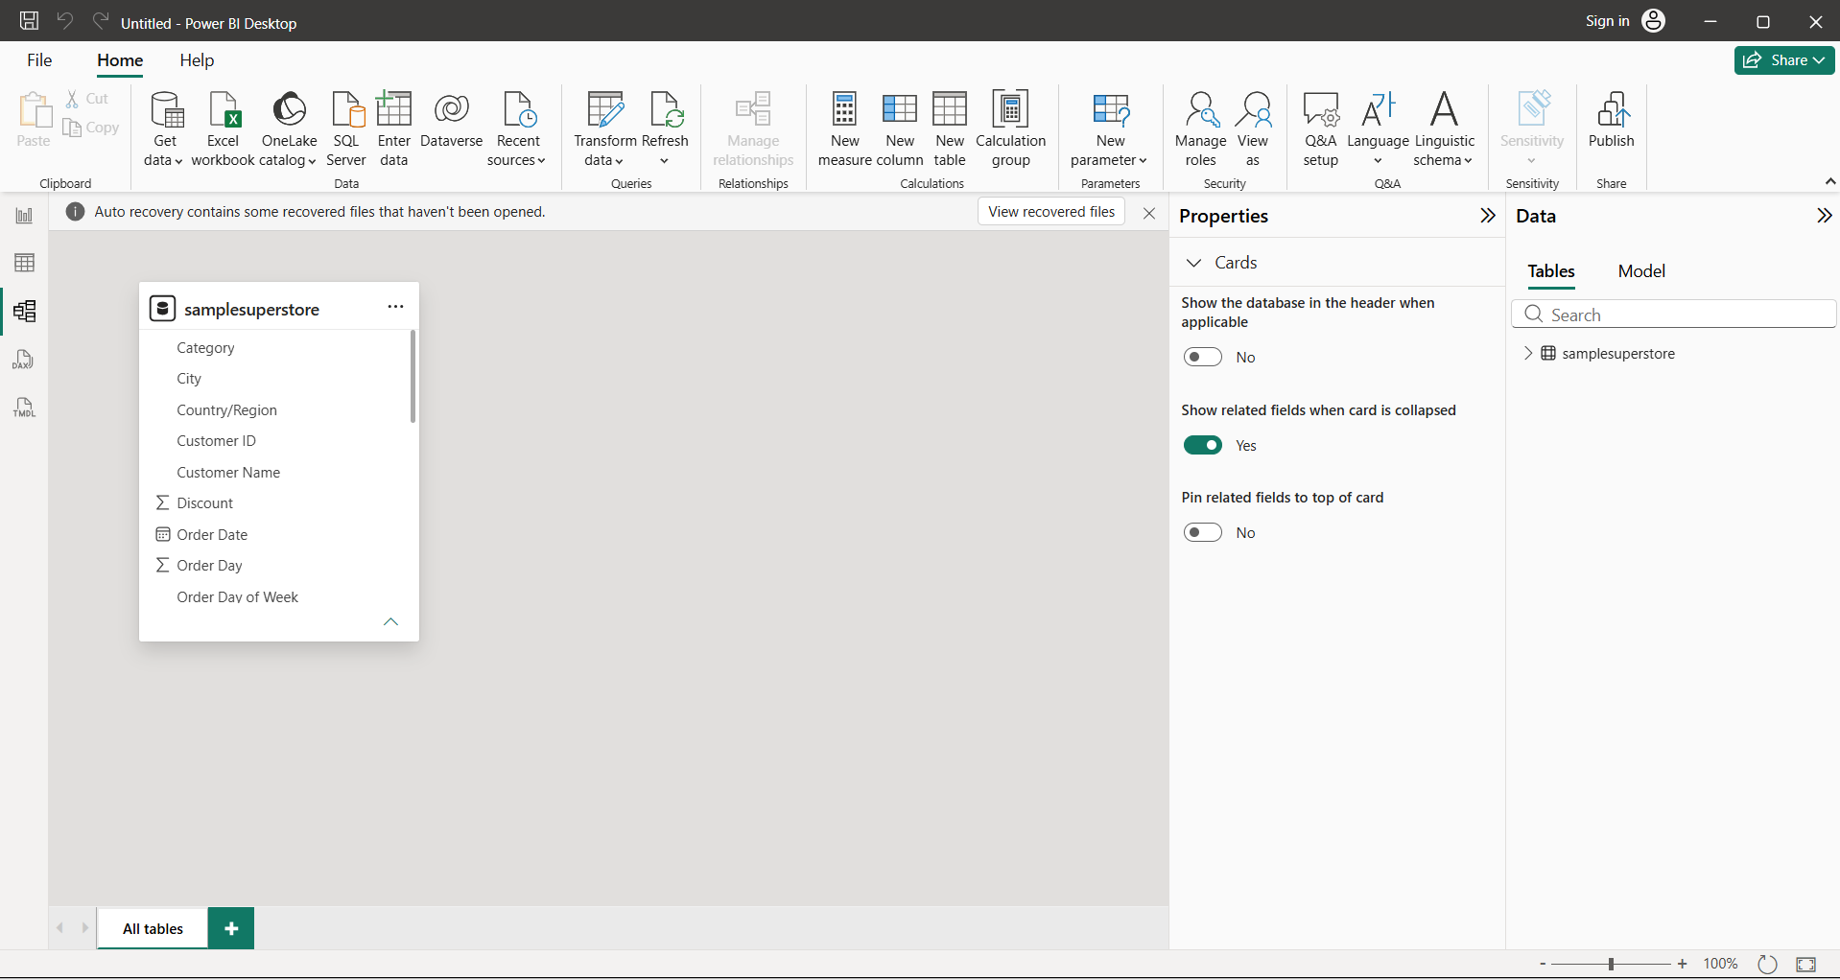
- The Order Month column was configured to sort according to Order Month Number, ensuring that months are displayed in chronological rather than alphabetical order. Similarly, the Order Quarter column was sorted using the Quarter Number column.
- 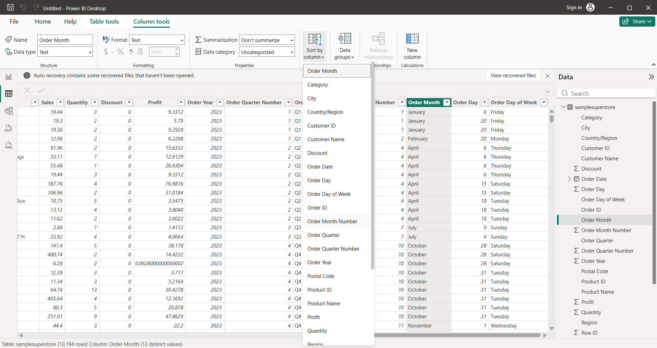
Order Month configured for chronological sorting using Order Month Number
Order Quarter configured for chronological sorting using Quarter Number column
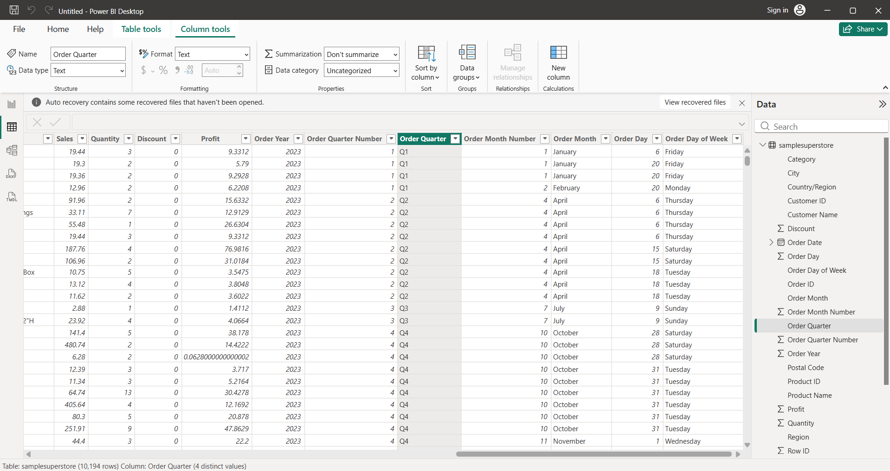
The file was successfully saved
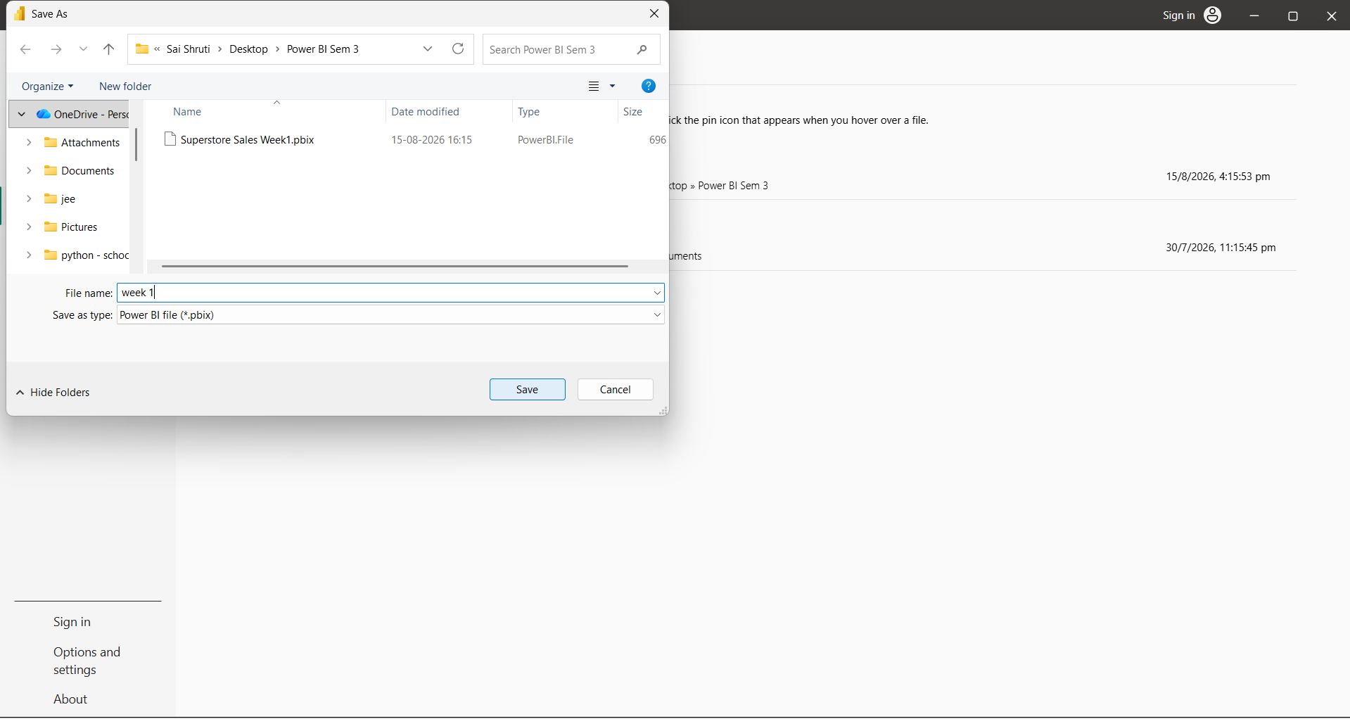

Conclusion
The Superstore Sales dataset was successfully ingested into the Power BI environment and subjected to a comprehensive data preprocessing and transformation workflow using the Power Query Editor. An extensive data quality assessment was performed to identify and rectify inconsistencies, anomalies, missing values, and formatting discrepancies within the dataset. Appropriate and contextually relevant data types were assigned to ensure data integrity and compatibility with subsequent analytical operations. Furthermore, textual attributes were systematically cleansed, standardized, and normalized to maintain consistency across categorical fields.
In addition, the Order Date field was leveraged to derive meaningful temporal dimensions, facilitating time-series analysis and enabling more granular examination of sales trends across different periods. Following the completion of the transformation and validation procedures, the refined dataset was integrated into the Power BI data model through the Close & Apply functionality. The resulting data structure was subsequently validated across the Report, Data, and Model views to ensure proper loading, relationships, and structural integrity. Consequently, the dataset is now comprehensively optimized and suitably structured for advanced analytical operations, interactive visualization, and subsequent dashboard development within Power BI.

